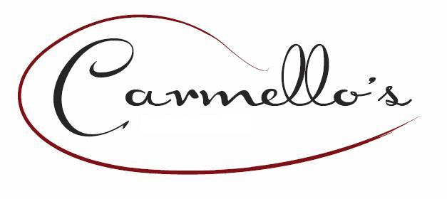
Presents ~~ Cakebread Cellars Valentine Wine Dinner
With Guest Speaker Guy Bell
Friday, February 10, 2023 at 6:30 PM
$150 (does not include gratuity or tax)

1st Course
APPLE & BRIE SALAD  hydro bibb fresh lettuce, grapes, apples, nut encrusted brie with smoked apple truffle vinaigrette | 2021 Sauvignon Blanc  Zesty aromas with grapefruit, lemon melon & citrus notes. More complex notes of green pear, cut hay & stony minerality. Light-bodied, elegant on the palate with bright acidity shining through. This was the first white grape variety that Cakebread Cellars planted in 1972 adjacent to the pond side winery.
2nd Course
SOPA de PEIXE  white fish, leeks, onions, celery, carrots spiced with garlic, bay leaves and saffron served with garlic parmesan bread | 2021 Chardonnay  Ripe green & golden apple open aromas, with light oak & fresh white peach notes emanate from this golden wine with a silky texture. Finishes with a clean appealing acidity that leaves smooth & silky as the final impression.
3rd Course

4th Course
LAVA CAKE  rich dark chocolate cake with fresh strawberries and zabaglione | 2019 Merlot  Deep aromas of blackberry & black cherry complemented with flavors of crushed stone & violet. Dark chocolate overtones complete the bold structured wine. Well balanced with bright acidity & fine-grained tannins leaves a long, spicy & smooth finish.
BRAISED BEEF SHORT RIBS  slow cooked short rib served with garlic red bliss mashed potatoes and broccolini | 2019 Cabernet Sauvignon  Reveals fragrant complex bouquet of rip blackberry & boysenberry, with notes of dark chocolate & toasty oak. Smooth & rich on the palate, dark fruits are balances with fresh acidity & lush tannins, leaving a lingering & elegant finish with a hint of minerality.

