PACKAGE INFORMATION
Carmello’s provides many options to ensure your event meets every expectation.

BOOKING A RESERVATION
Once you have had the chance to review our service offerings, your next step is to contact Stephen, our general manager at 703-368-5522 or via email: stephen@carmellos.com . In order to reserve your date and time, a deposit of $750 is required. Your deposit is applied to your balance the day of your event.
Save the date deposits are non-refundable. Your reservation can only be booked if you put down a deposit otherwise we cannot hold the room.

GRATUITY
A 20% gratuity will be added to the bill for service. You are more than welcome to leave more for exceptional service.

FOOD & BEVERAGE MINIMUM
Amounts shown are for one room. If two rooms are needed a custom price can be arranged. (there is no rental fee, this is the minimum amount spent on food and beverage before tax and gratuity)

Monday & Tuesday
First 2.5 hours $1500, additional $350 per hour

Sunday, Wednesday & Thursday
First 2.5 hours $750, additional $250 per hour

Friday & Saturday
First 2.5 hours $2000, additional $500 per hour

HOURS OF OPERATION
Our banquet rooms are available to rent between 11 am and 11 pm seven days a week. Carmello’s is closed on the following days: New Year’s Day, Memorial Day, Labor Day, Thanksgiving and Christmas.
STATE & LOCAL TAX
6% Commonwealth of Virginia Sales Tax
4% City of Manassas Meals Tax

PACKAGE ONE

Bread Basket
Plated Carmello’s Garden Salad
Entrées (choice of 2)
Sides (choice of 2)
Dessert (choice of 2)
$48 per person

PACKAGE TWO

Appetizers (choice of 3)
Bread Basket
Plated Salad (choice of 2)
Entrées (choice of 3)
Sides (choice of 2)
Dessert (choice of 2)
$58 per person

PACKAGE THREE

Appetizers (choice of 4)
Bread Basket
Plated Salad or Soup
Entrées (choice of 3)
Sides (choice of 2)
Desserts (choice of 3)
Champagne or Cider Toast
$72 per person

CUSTOM PACKAGE

Don’t see anything that fits? We would be happy to customize a package specific to your needs. We are experienced in handling all types of events from wedding rehearsal dinners, showers, presentations, conferences, birthday, anniversary and holiday parties. Note that pricing may be subject to change if reservation is 8 months to 1 year booked in advance. This is due to supplier price changes.

BEVERAGES

Non-alcoholic beverages including coffee, tea, soda, and water are included in all packages.

We offer an espresso, cappuccino, and latte package for $9 per person.

BEER, WINE, AND LIQUOR

The full range of Carmello’s beer, wine and liquor offerings are available and are charged based on consumption.
We will work with you to tailor your beverage offerings for your event. You may offer any combination of alcoholic choices at your expense or at your guests expense.
Common examples are offering only beer and wine, limiting the number of drinks per guest, limiting the cost per drink, or limiting the total amount spent on alcohol on your check.

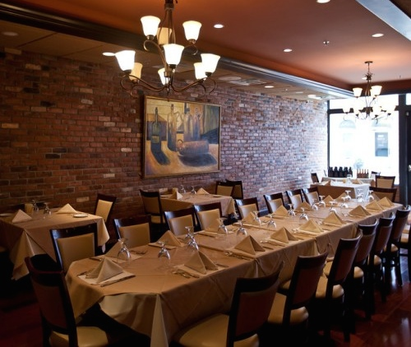

APPETIZERS

BRUSCHETTA
Tomatoes marinated in olive oil with garlic and basil, served on crispy bread and topped with creamy feta cheese

RISOTTO FRITTERS
Risotto stuffed with mozzarella cheese lightly breaded and fried

STUFFED MUSHROOMS FIORENTINA
Stuffed with spinach, bacon and pine nuts

SPITADA DE CAMARAO
Jumbo shrimp grilled and served in a lemon vinaigrette

MINI BEEF WELLINGTONS
Puff pastry stuffed with filet tips, shallots and mushrooms, drizzled with demi-glace

CALAMARI FRITTI
Lightly battered and fried squid

SALAD OPTIONS

PORTUGUESE SALAD
Cucumbers, red onion, black olives, baby greens and sliced tomato with our Portuguese vinaigrette

CARMELLO’S GARDEN SALAD
Tomatoes, chickpeas, carrots and baby greens with a homemade creamy Italian dressing

CAESAR SALAD
Traditional Caesar salad with our homemade Caesar dressing accompanied with a crostini

ENTRÈES

LOMBO DE PORCO A PORTO
Pork tenderloin wrapped in bacon with a peppercorn demi-glaze

Gamberi Griglia Genovese
Marinated jumbo shrimp, angel hair pasta, julienne vegetables, sundried tomatoes and pine nuts, sautéed and tossed in pesto wine sauce

Bacalhau Fiorentina
Pan seared fresh filet of cod on a bed of sautéed spinach with garlic white wine sauce

SALMON MAESTRO
Salmon, broiled and served with a champagne sauce with fresh herbs and a touch of lemon

CHICKEN PIEDMONTESE
Chicken breast sautéed with Italian sausage, roasted peppers, and tomatoes with a white wine lemon butter sauce

CHICKEN MARSALA
Chicken breast sautéed in a Marsala demi-glace with mushrooms

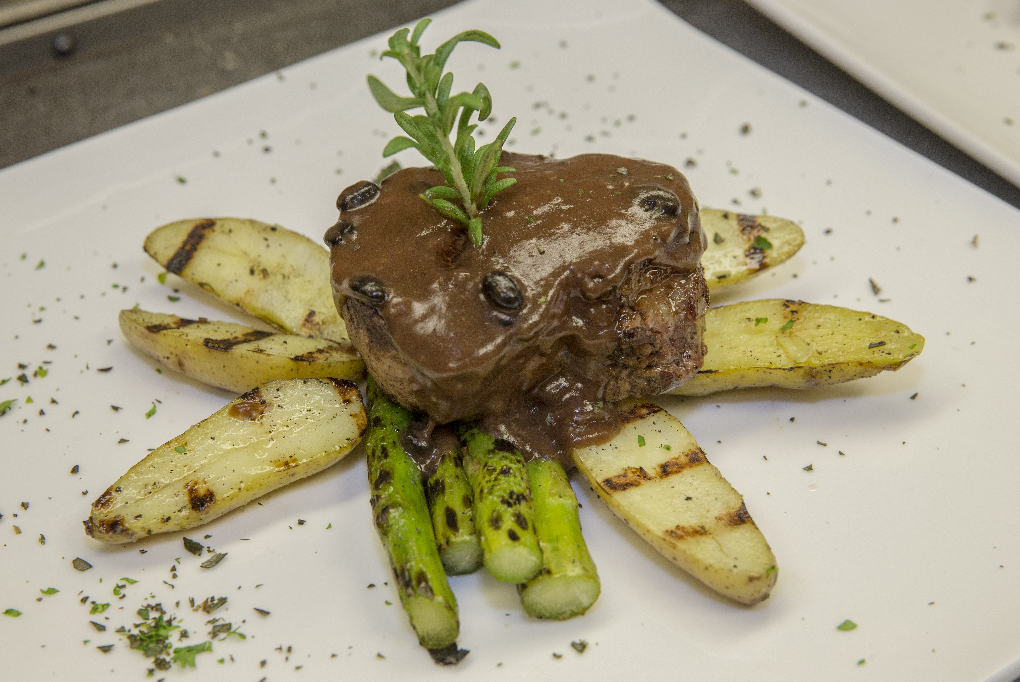
Lombo de Vaca

PREMIUM ENTRÉES (+$3 to package price to add any or all of these options)

**Lombo de Vaca
7 oz. Filet mignon grilled and served with a Madeira wine demi-glace with mushrooms

VEAL PICATTA
Medallions of fresh veal sautéed in a white wine lemon butter sauce garnished with capers

Paella Valenciana
Chouriço, chicken, calamari, clams, mussels with tomato saffron rice

PASTA OPTIONS

RAVIOLI ALLA ROSE
Homemade lobster ravioli garnished with seasonal vegetables with a lobster cream sauce

AGNOLOTTI CON PESTO
Ricotta cheese and spinach stuffed agnolotti served with artichoke hearts in a pesto cream sauce

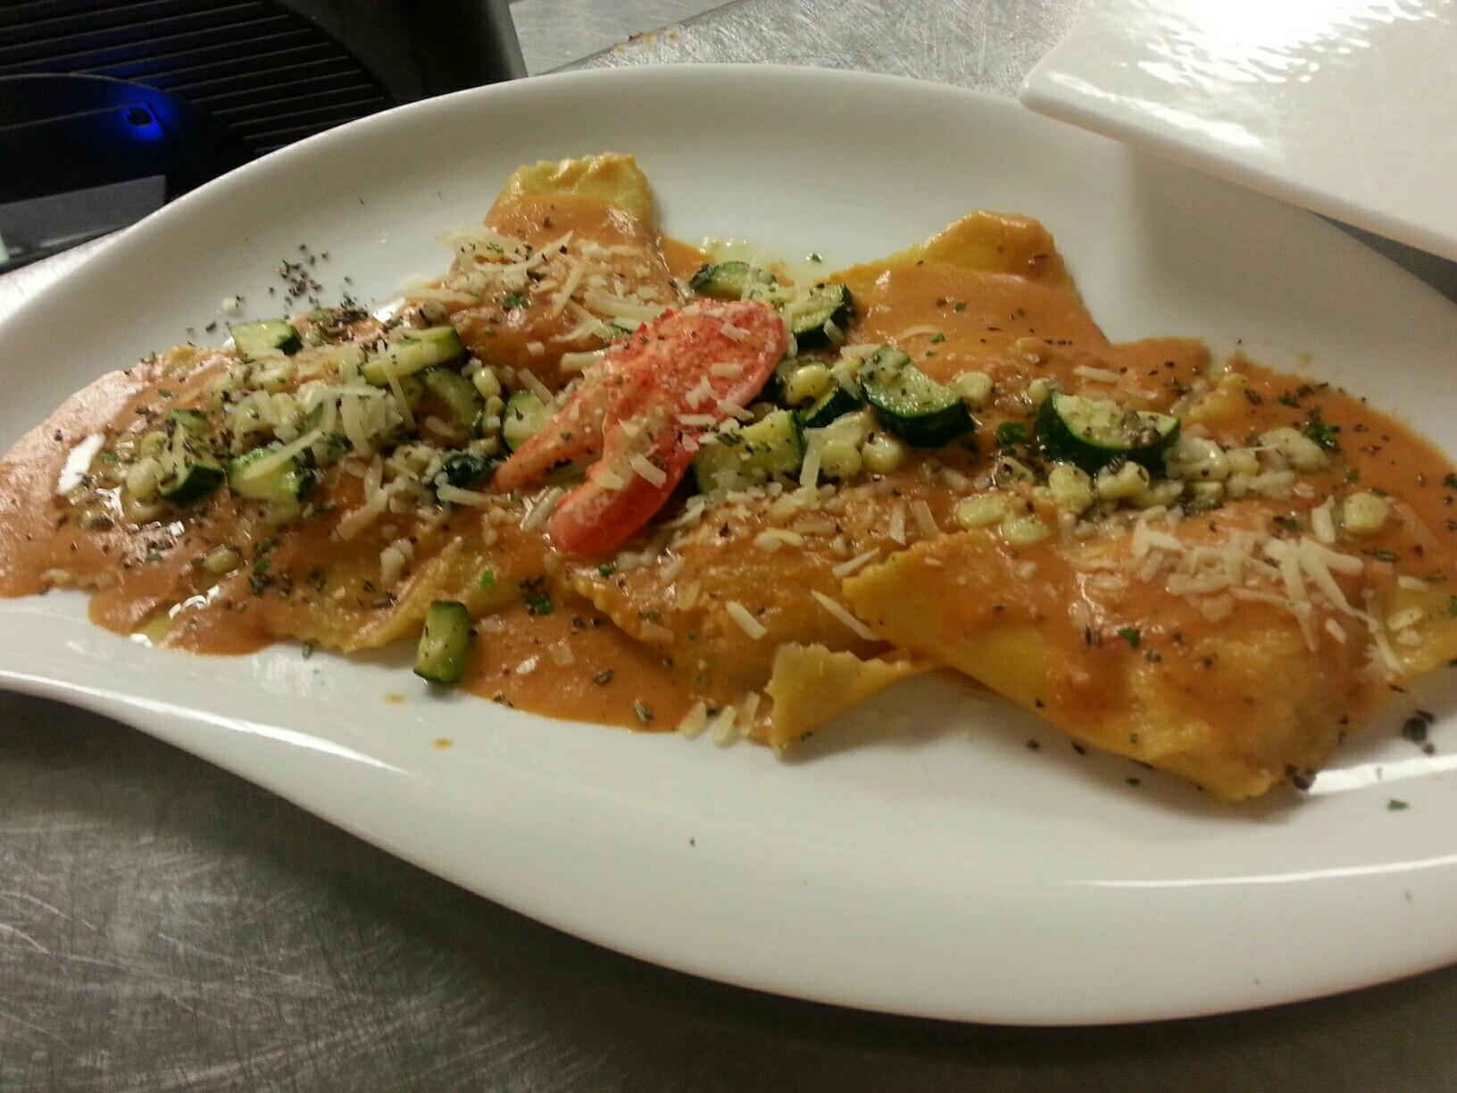
Ravioli alla Rose

SIDES
Goat Cheese Mashed Potatoes
Garlic Herb Mashed Potatoes
Garlic Herb Roasted Potatoes
Penne Pasta with Marinara or Garlic Olive Oil
Seasonal Vegetables

DESSERT

CHOCOLATE HAZELNUT CAKE

ITALIAN TIRAMISU

NEW YORK STYLE CHEESECAKE

VANILLA BEAN CRÈME BRÛLÉE

FRUIT SALAD

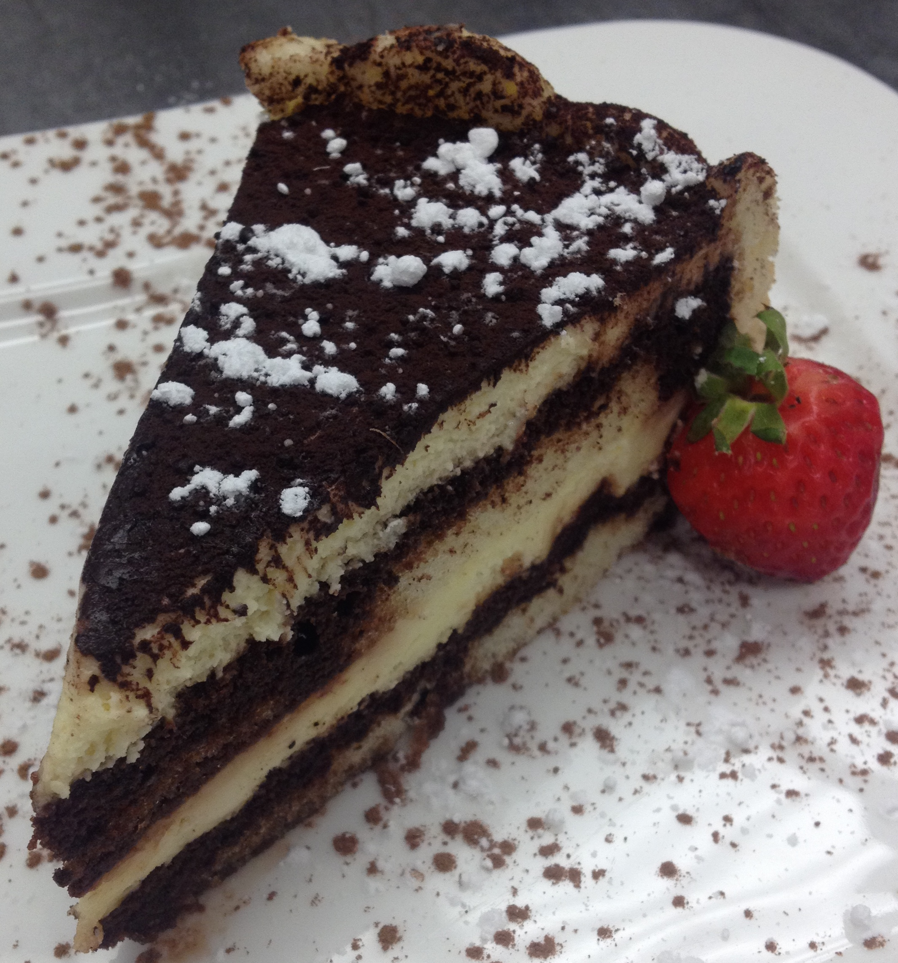

We have other entrée items available. This is just a small sample of items we can prepare for your event.

**All beef entrées are prepared medium unless otherwise specified.

FREQUENTLY ASKED QUESTIONS

WHERE CAN WE PARK?
Free street parking is available after 5 pm everyday and on weekends. Parking garage is located on Battle Street and Prince William Street one block away.

WHEN IS FINAL GUEST COUNT DUE?
One week before your event. This number is the minimum that you will be charged for. If you have guests that aren’t sure they can attend it is best to leave them out of this count. It is okay to add up to 4 people two days prior to your event, please notify your banquet coordinator as soon as possible.

CHILDREN’S PRICING AND MENU
Pricing for children range from $8 - $12 per child.
We have a full children’s menu available.

HOW MANY PEOPLE CAN WE ACCOMMODATE?
Out wine room fits up to 40 guests. Our larger room fits up to 65. For parties greater than 65 guests, both rooms can be booked and combined.

TASTING
We offer tastings at a cost of $25 per person for up to four guests. You may try up to 4 appetizers, 2 salad/soups, 3 entrées and 2 sides. Desserts are additional.

DO YOU HAVE VEGAN, VEGETARIAN, AND GLUTEN FREE MENU ITEMS?
Yes, we can make individual items to suit dietary or allergy needs.

IS MY SAVE THE DATE DEPOSIT REFUNDABLE?
No, save the date deposits are non-refundable.

CAN I DECORATE THE ROOM?
Decorations are limited to the tables. No confetti please. Nothing may be placed on the walls, the ceiling, or the credenza. We can take delivery of floral arrangements 24 hours in advance.

HOW MANY HOURS CAN WE RESERVE THE BANQUET ROOM?
As many as you like as long as you meet the food and beverage minimum

HOW DO YOU RESERVE THE BANQUET ROOM?
Once you have had the chance to review our service offerings, the next step is to contact Stephen, our banquet coordinator and check for availability. In order to reserve your date and time, a deposit of $750 is required. The deposit is applied to your balance the day of your event.
Save the date deposits are non-refundable. Your reservation can only be confirmed once a deposit is made to hold the room.

SEATING ARRANGEMENTS?
Our standard set-up are rounds that seat 6-7 guests. Standard rehearsal dinner tables are u-shaped, according to the amount of guests to be seated this may change.

CAN I BRING MY OWN DESSERTS?
Yes, as long as they are from a professional bakery. Cake cutting/plating fee is $2.5 per person.

CAN WE BRING IN OUR OWN WINE?
Yes, we have a $25 per 750 ml bottle corking fee.

MUSIC
We provide light background music. We do not allow DJ’s, live bands or any amplified music.
