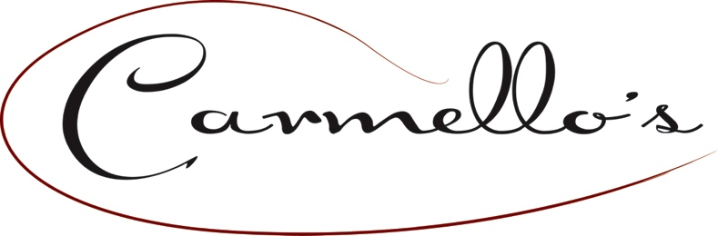
HAPPY FATHER’S DAY!

Our menu focuses on elevating traditional Portuguese & Italian dishes by offering a taste of the
classic favorites and a view of the contemporary flavors of the season.

APPETIZERS

FRESH STRAWBERRY BRUSCHETTA
Lemon Crème Fraîche, Toasted Almonds, Basil, Balsamic Reduction 14
SMOKED SALMON CROSTINI
Chive Cream Cheese, Smoked Salmon, Capers, Fresh Dill 15

PORTUGUESE FLATBREAD
Chouriço, Hard Boiled Eggs, Olives, Onions, Mozzarella & Parmesan Cheese 15

BACON AND HONEY BAKED BRIE
Melted brie with bits of crispy bacon, dried cranberries, granny smith apples, honey. freshly toasted basil and herb croutons 15
PICADAS DE BIFE
Filet Mignon Tips, Garlic, Extra Virgin Olive Oil, Salt, Pepper, Parsley, Hydro-Bib Lettuce, Port Wine Reduction 15

ENTREES

SHRIMP AND GRITS SOUTHERN STYLE
Cheesy Grits with Smoked Cheddar, Bacon, Bell Red Peppers, Blackened Shrimp 30

CHOCOLATE BELGIAN WAFFLES WITH FRESH BERRIES & CRÈME FRAICHE MASCARPONE
Flour, Buttermilk, Eggs, Vanilla, Cocoa, Mascarpone Crème Fraîche, Strawberries, Blackberries, Lemon Zest 20

FILET OSCAR AND EGGS
6 oz Petite Filet Mignon, Jumbo Lump Crabmeat, Asparagus, Hollandaise Sauce, 2 Eggs Any Style, Crispy Oven-Fried Red Potatoes 38

LOBSTER & SHRIMP AVOCADO BENEDICT
Toasted Sliced English Muffin, Lobster Meat, Jumbo Shrimp, Poached Eggs, Avocado, Hollandaise Sauce, Crispy Oven-Fried Red Potatoes 39

SEAFOOD OMELETTE
Shrimp, Scallops, Crab, Eggs, Cream, Monterey Jack & Cheddar Cheeses, Crispy Oven-Fried Red Potatoes 30

STEAK AND EGGS
10 Oz Boneless Prime Rib, Two eggs Any style, Home Made Portuguesa Home Fries 39
COSTELLAS DE CORDEIRO
Grilled Rack of Lamb, Garlic, Olive Oil, Potatoes Au Gratin, Grilled Broccolini, Chianti Demi-Glace 45

VEGAN BOWL
Grilled Portabella, Roasted Root Vegetables, Quinoa, Black Beans, Roasted Fresh Garlic, Cippolini Onions, Balsamic Vinaigrette Reduction 25

AMERICAN BREAFAST
Three Eggs, Bacon, Sausage, Ham, Toast, Roasted Crispy Red Potatoes 25

